A week in the life of a Commissioner
A Commissioner doesn’t spend all their time desk-bound in our offices in London. The role is incredibly varied. The extract below details a week in the life of one of our Commissioners:
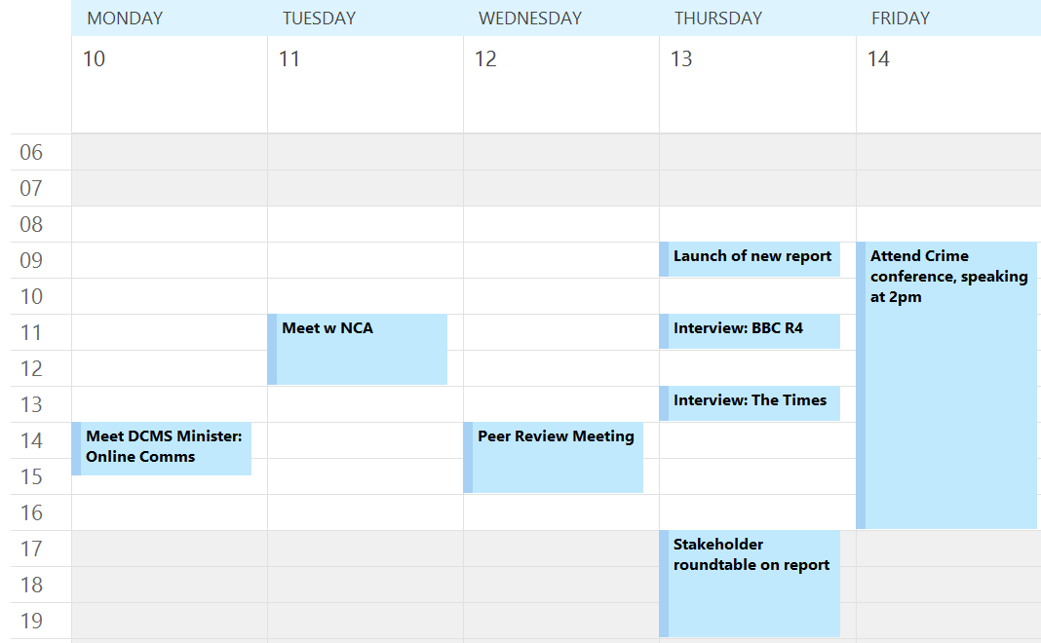

In any given week the Commissioner could be doing some or all of the following:
- Meeting Government ministers (or other politicians) to discuss a project and the Commission’s recommendations.
- Liaising with senior judiciary.
- Meeting a range of stakeholders to understand how proposals would affect them.
- Attending, hosting and speaking at roundtables or conferences to engage with and explain our proposals to various interested parties.
- Taking part in media interviews for TV, radio and newspapers. This is especially important when launching a report but is also required during other times.
- Peer reviewing the Commission’s work to ensure all published work is of the highest quality, protecting the reputation of the Commission.

